# OOP – Environment System

The goal of this lab is to study the **Environment System** and extend its functionality. You are **NOT allowed to directly edit** any of the contents of the **Core** and **Interface** namespaces (only the **Generator** namespace).

## Melting Snowflakes

Good, the snow now hits the ground properly, but shouldn't it also…melt? …and produce snow in the process?

### Step 1 – Melting Snowflakes

Whenever a snowflake hits the ground it should not only cease to disappear, but produce **snow**. What is actually snow? – it is something that the **snowflake produces with quantity of 1**. It may look however you wish (e.g. '**.**', to distinguish it from snowflakes).

Note: You are only allowed to edit the contents of **Models.Objects** namespace.

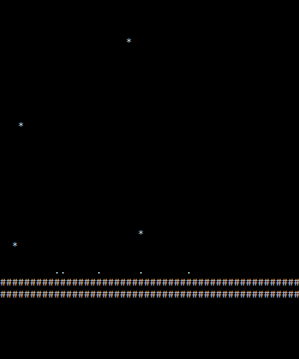

If you look close enough, the little dots on the ground are '.', whereas the snowflakes are '*'. The dots were created when the snowflakes hit the ground.

### Step 2 – Stacking Snow

Make so that snow stacks – i.e. if a snowflake falls on snow – it produces more snow.

Notice how at certain places the snow has stacked:

